**Online User Interface Implementation**

Architectural Diagram:

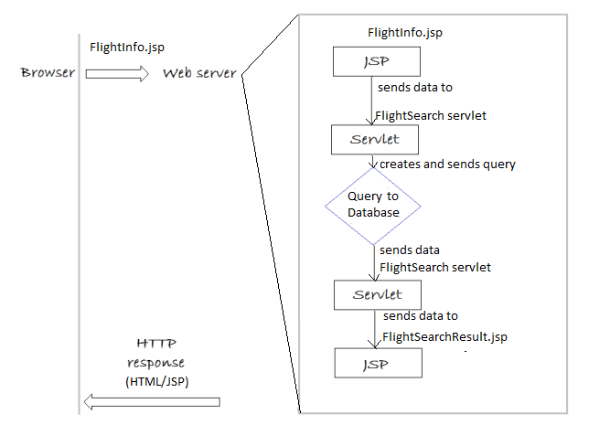

Note: This diagram can be applied to any of the requests.

Implementation Explanation:

1. We followed the MVC model to retrieve and display data from the database.

2. Requests are sent to servlets which then create and execute queries on the database.

3. When queries are finished executing, the data are returned back to the servlet.

4. The returned data in the servlet are sent to the appropriate JSP to be displayed.

5. The JSP is sent back to the browser to be displayed.